Lucie Petráková, 214014
Filip Pultar
AJ1101 Practical Language 1A (Combined)
23rd November 2022
Please, do not delete any of the following boxes (Assessment, Notes, Assessment scales)
ASSESSMENT
Content | Organisation | Communicative Achievement | Language
2.5 | 2.5 | 2.5 | 2.5
Points: |  | 10

NOTES
✓ | appropriate  lexis / grammar | accurate use of advanced grammatical forms or lexis
L | language | inappropriate or inaccurate use of an expression; incorrect grammar; basic/simple language (significantly below the B2-C1 level)
R | register | inappropriate use of the variety of language used for a particular purpose or in a particular communicative situation (e.g. too formal/informal)
S | spelling | a spelling mistake or inconsistency in the use of different varieties of English (e.g. BrE / AmE)
B | ‘to be’ | unnecessary use of the verb ‘to be’ which can be replaced by a more precise and appropriate expression
Re | repetition or redundancy | unnecessary repetition or redundant sections which add little relevant content
? | lack of clarity | a section which makes little sense, lacks clarity, or impedes communication in some way; a section which does not contain sufficient information and requires elaboration
C | cohesion | the section lacks appropriate cohesive devices or linking words
wo | word order | incorrect or inappropriate word order
ASSESSMENT SCALES


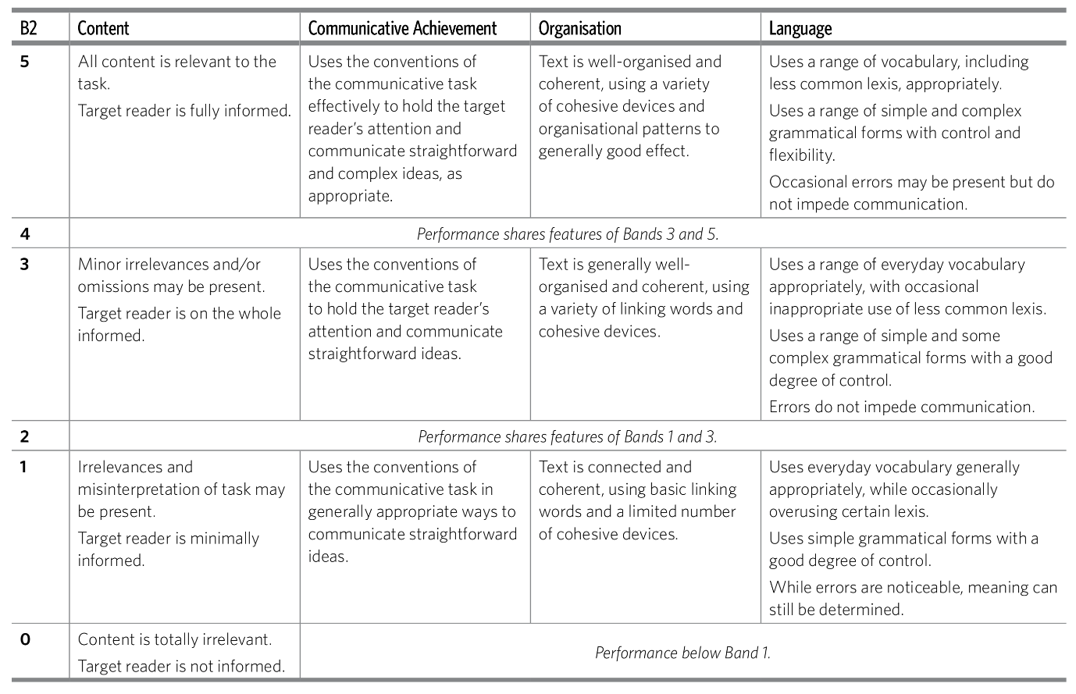

Money cannot buy you happiness

The statement “money cannot buy you happiness” is often presented as a general truth. Even advertisements claim that. However, they still urge you to buy their product. Is the statement that money cannot buy you happiness accurate or does it need to be revised?
Money is connected to a sense of security. When you cannot afford necessary things, like fix or place to live, it can cause you unhappiness. People think that more money would fix their problems or even bring them happiness, and a big amount of money would mean a comfortable life without any problems. Although the solution to our troubles is rarely so simple, I must admit that not thinking about fulfilling some basic needs like the sense of security can help in pursuing other important things in life.
Moreover, money can buy you better education and better treatment in school. While there are many public schools that offer great service, you stand a better chance with a private one. Even in public schools, when an assistant is required for a child with special needs, his work costs the school more money.
Generally, being able to provide money to people in need seems very fulfilling and I believe it makes those charitable people happy. Even as a child I experienced a great feeling being able to get Christmas presents for all my family.
In conclusion, I cannot prove that money can buy you happiness, yet I believe it lays the groundwork for achieving it.

