Lucie Petráková 214014
Filip Pultar
AJ2102 Practical Language 1B
DATE 25th Mars 2023
Please, do not delete any of the following boxes (Assessment, Notes, Assessment scales)
ASSESSMENT
Content | Organisation | Communicative Achievement | Language
4 | 4 | 4 | 4
Points: |  | 8

NOTES
✓ | appropriate  lexis / grammar | accurate use of advanced grammatical forms or lexis
L | language | inappropriate or inaccurate use of an expression; incorrect grammar; basic/simple language (significantly below the B2-C1 level)
R | register | inappropriate use of the variety of language used for a particular purpose or in a particular communicative situation (e.g. too formal/informal)
S | spelling | a spelling mistake or inconsistency in the use of different varieties of English (e.g. BrE / AmE)
B | ‘to be’ | unnecessary use of the verb ‘to be’ which can be replaced by a more precise and appropriate expression
Re | repetition or redundancy | unnecessary repetition or redundant sections which add little relevant content
? | lack of clarity | a section which makes little sense, lacks clarity, or impedes communication in some way; a section which does not contain sufficient information and requires elaboration
C | cohesion | the section lacks appropriate cohesive devices or linking words
wo | word order | incorrect or inappropriate word order

ASSESSMENT SCALES
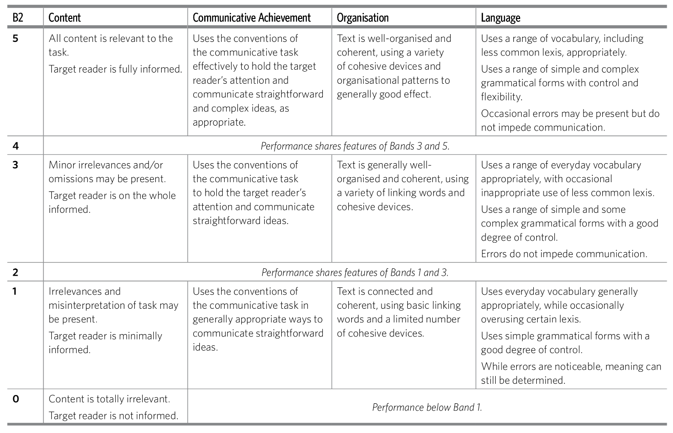The Review
The South Corean series called Squid game has been available on Netflix since 2021. Despite or maybe thanks to quite a violent trailer, it became an overnight sensation. The plot revolves around a game for a large sum of money. Main protagonist finds himself in an unknown place with 200 other heavily indebted people. They are participants in a series of children’s games, the ultimate winner is promised an astronomical sum of money. What none of them realises is that losers are condemned to death.
The main character is at the beginning portrayed as a week man with many flaws, however during the series he evolves and becomes a compassionate and strong person. His playmates come from very different background, the only thing they have in common is debt. In the course of events, they accept the premise, either to win or lose their life. The order is secured by masked guards, it’s them who ultimately punish people. Thanks to the ubiquitous fear and to a sterile environment, the atmosphere of the series is very oppressive. Moreover, the participants are further dehumanised by being addressed by their number and by being obliged to wear matching clothing.
Creators as well as writers deserve praise for realizing such a captivating series. If I look away from violent scenes that are depicted, the series addresses many important issues. The violence is used to shock the audience and the improbable but very disturbing storyline makes you think about your values and your place in the society.

A well written review, the main content points have been met, but more information could have been given about other aspects of the series. The register is suitable for the task and consistent throughout. The text is well organised and you have used a range of simple and complex grammatical structures. The mistakes present tend to be slips rather than systematic in nature and they do not prevent comprehension.

